CJ Lab Worksheet – Session 1
Roll No:24302B0062
Division:B
Batch: 5
Topic: Loops, datatypes and operators
Case Study: Classroom Management System (Command-Line Interface)
A software company is developing a small utility module for a classroom management system. The module needs to perform simple logical checks, repeated notifications, and arithmetic calculations based on teacher inputs.
As a junior Java developer, you are asked to implement the following features:

Task 1 – Boolean Check
The system must verify whether a student has completed the assignment. You are required to create a Java program that demonstrates the use of a Boolean variable and prints its value.
CODE:
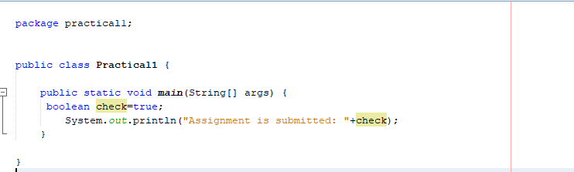

OUTPUT:
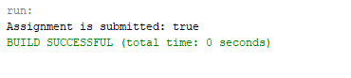

Task 2 – Repeated Notification
The system must display a reminder message 10 times using a for loop so that students do not forget to submit their work.
CODE:
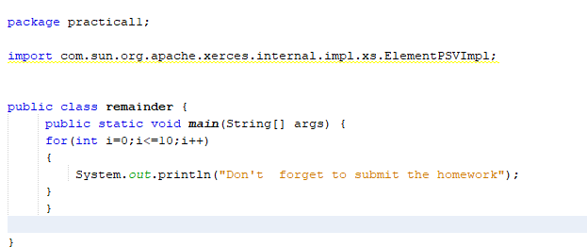
OUTPUT:
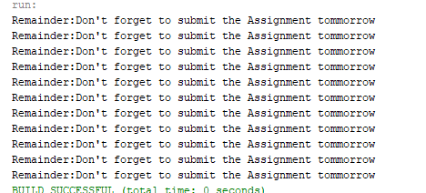

Task 3 – Arithmetic Expression Evaluation
Teachers will input three integers a, b, and c, and the system must evaluate the arithmetic expression:
a + b * c % d
and display the result.
CODE: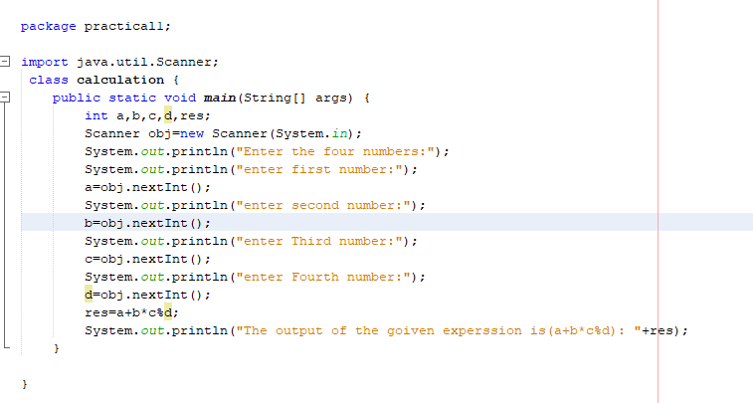

OUTPUT:
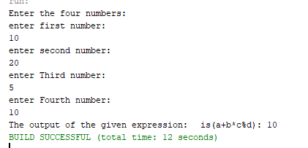

Take Home Task:
- A school wants to build a tiny calculator that helps students check their marks. The system should take the student’s name, two subject marks, and then calculate the total and average.
- As a Java developer, create a program that:
- Uses different data types (String, int, double)
- Takes input from the user
- Performs evaluation (total + average)
Code:

Output:

